New dates !  
October 3-4th 2015

To the managers of softball teams

*Subject :* **Invitation to the Luis Aparicio International Fastpitch Softball Tournament for men and women**

You are invited to the Luis Aparicio International FASTPITCH SOFTBALL OUTDOOR Tournament FOR MEN AND WOMEN organized by the Raiders Baseball Softball Club in Eysines.

The tournament will take place on **October 3-4th of 2015**.

**10 teams** can participate on 3 fields and will play on Saturday from 10:00 am to 06:00 pm and on Sunday from 10:00 to 04:00 pm.

Cocktails and a hot dinner (appetizer, starter, main course, dessert and wine) prepared by a caterer are proposed and served for €14 on Saturday evening, followed by a party.

The organizing committee provides during the day a catering service at the refreshment bar "Los Plancha Kings“, offering a large variety of menus, exotic sandwiches and drinks in a multi-cultural ambiance.

Each team will be asked to provide 6 hard softball balls for its participation in the tournament as well as a deposit of €150 released at the end of the tournament and to be transferred to:

**ASS THE RAIDERS EYSINES  
IBAN : FR76 1090 7000 0105 0215 1425 384 Swift/BIC : CCBPFRPPBDX**

**All the participants must be registered in a national federation.**

You will find enclosed a registration form for men and women teams that has to be fulfilled and sent back **before September 12th** with the deposit bank transfer. Only the first registrations will be confirmed; the others will be placed in a waiting list.

The tournament rules and the timetable will be provided later.

Best regards,

Eduardo MACHADO, President

**Presentation of the 20th Luis Aparicio International Fastpitch Softball Tournament for men and women on October 3-4th 2015**

Those who already know tournament can testify its high standard of level, thanks to the presence of teams with European exposure. Not forgetting the “Fun” state of mind of this sport, its friendliness within a splendid frame (the lowland of 25 hectares of Pinsan, its sports installations and especially its bare swimming pool that can receive the players, their family and friends).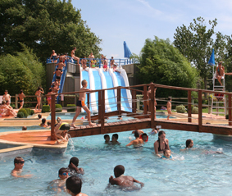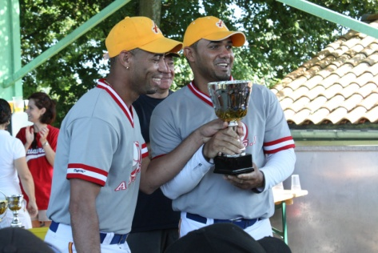

On the top of that, the organisation provides a catering service every day at the refreshment bar " Los Plancha Kings “, offering a large variety of menus, exotic sandwiches and drinks in a multi-cultural ambience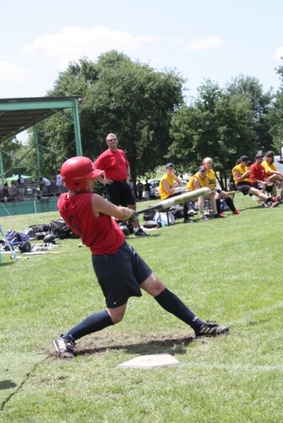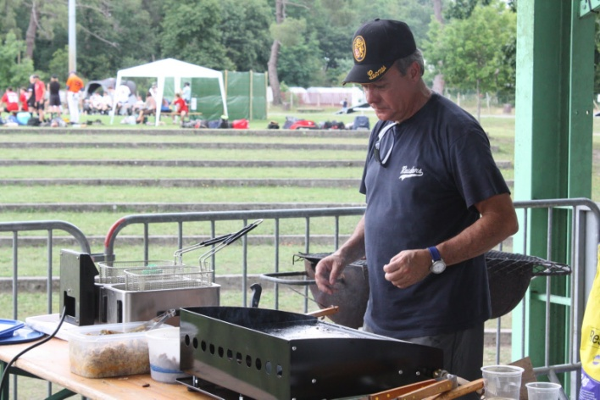

Cocktail and dinner are prepared by a caterer, and are served on Saturday evening, followed by a party.

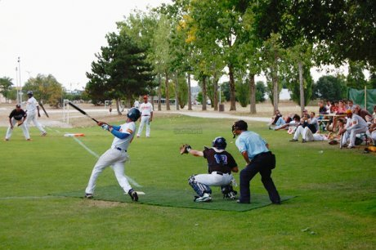

**REGISTRATION FORM LUIS APARICIO TOURNAMENT**

**OCTOBER 3-4th 2015**

Name of Club :

Address :

Contact:

Tel :

EMail :

I, ……………………………………………………………. , manager of the ……………………………………………….. wishes to enter

……… adult men team(s)

……… adult women team(s)

for the 2015 Luis Aparicio International Tournament

Please find enclosed:

……… x 6 hard balls : *participation in the tournament, to be provided at your arrival*

……… x € 150 *deposit by bank transfer (to be released at the end of the tournament)*

……… x € 14: *reserved dinners for Saturday night*

Name and Signature of the club manager:

**Registration Men team**

**Team name** : ..................................................

|  |  |  |  |  |
| --- | --- | --- | --- | --- |
| **Players :** tick the ones who will have dinner on saturday (x€14) | | |  |  |
|  | **SECOND NAME** | **FIRST NAME** | **CLUB** | **DINNER** |
| 1 |  |  |  |  |
| 2 |  |  |  |  |
| 3 |  |  |  |  |
| 4 |  |  |  |  |
| 5 |  |  |  |  |
| 6 |  |  |  |  |
| 7 |  |  |  |  |
| 8 |  |  |  |  |
| 9 |  |  |  |  |
| 10 |  |  |  |  |
| 11 |  |  |  |  |
| 12 |  |  |  |  |
| 13 |  |  |  |  |
| 14 |  |  |  |  |
| 15 |  |  |  |  |
|  |  |  |  |  |
| **Others :** | |  |  |  |
| 1 |  |  |  |  |
| 2 |  |  |  |  |
| 3 |  |  |  |  |
| 4 |  |  |  |  |
|  |  |  |  |  |

**Registration Women team**

**Team name** : ..................................................

|  |  |  |  |  |
| --- | --- | --- | --- | --- |
| **Players :** tick the ones who will have dinner on saturday (x€14) | | |  |  |
|  | **SECOND NAME** | **FIRST NAME** | **CLUB** | **DINNER** |
| 1 |  |  |  |  |
| 2 |  |  |  |  |
| 3 |  |  |  |  |
| 4 |  |  |  |  |
| 5 |  |  |  |  |
| 6 |  |  |  |  |
| 7 |  |  |  |  |
| 8 |  |  |  |  |
| 9 |  |  |  |  |
| 10 |  |  |  |  |
| 11 |  |  |  |  |
| 12 |  |  |  |  |
| 13 |  |  |  |  |
| 14 |  |  |  |  |
| 15 |  |  |  |  |
|  |  |  |  |  |
| **Others :** | |  |  |  |
| 1 |  |  |  |  |
| 2 |  |  |  |  |
| 3 |  |  |  |  |
| 4 |  |  |  |  |
|  |  |  |  |  |

**Useful contacts**

**Eduardo Machado J.François Allafort David Quintard Stéphane Giraud**

***(President &*** *French / English**French / English French / English*

***Resp. Spanish teams)***

Tél : +337 81 31 26 31 +335 57 22 81 41 +336 75 62 14 66 +336 73 93 04 46

+335 56 172 623

[emachadobx@gmail.com](mailto:emachadobx@gmail.com) [j.f.allafort@sciencespobordeaux.fr](mailto:j.f.allafort@sciencespobordeaux.fr) [davidquintard@hotmail.fr](mailto:davidquintard@hotmail.fr) [stgiro@aol.com](mailto:stgiro@aol.com)

**Hotels**

**Hôtel Première Classe**

Rue du Champ de Course

33320 Eysines

T : +33 **892 707 216**

[www.premiereclasse.com/fr/hotels/premiere-classe-bordeaux-ouest-eysines.fr](http://www.premiereclasse.com/fr/hotels/premiere-classe-bordeaux-ouest-eysines.fr)

**Hôtel Quick Palace**

Impasse Paddock

33320 Eysines

T : +33 556 575 314

[www.quickpalace-bordeaux.fr](http://www.quickpalace-bordeaux.fr)

**Hôtel Formule 1**

Allée Cantinole

RN215

33320 Eysines

T : +33 891 705 191

<http://www.hotelf1.com/fr/hotel-2360-formule-1-hotelf1-bordeaux-ouest-eysines>

**Balladins Hôtel**

11 Allée du Champ de Course

33320 Eysines

T : +33 556 281 962

[www.balladins-eysines.com](http://www.balladins-eysines.com/)

**Hôtel Les Alizés**

15 avenue de Saint Médard

33320 Eysines

T : +33 556 283 652

[www.**hotel**-alizes-bordeaux.com](http://www.hotel-alizes-bordeaux.com)

**Acces map to the PINSAN’s fields  
 from highway exit #8**

